1305, 12 Glen St
Milsons Point NSW 2061
0434 715.861
scribepj@bigpond.com

4 June 2021

Ms. Mara Greenwood
Regional Manager, School to Work program
National Rugby League H.O.
Locked Bag 5000
Paddington, NSW 2021

Dear Mara

Invitation to Eight NRL ‘School to Work’ administrators to review
'Aboriginal Teenager Life Skills’ RTV Social Inclusion Early Intervention Program

I am a retired Infrastructure banker who studied for 10 years attaining two finance degrees from Macq Uni. I worked for CBA for 37 years.

Drawing upon my skills attained during 18 years in Infrastructure Finance, I have expended several hundred hours preparing a Business Plan for
'Aboriginal Teenager Life Skills’ RTV Social Inclusion Early Intervention Program because –
- Australia’s indigenous citizens have been poorly treated since British settlement
(I did not appreciate that until I watched a documentary series, ‘First Footprints’, which exposed a proud and highly self-sufficient race of people that respected the land); and
- Federal Govt funding of Preventative Health Programs to assist indigenous Australians has proven highly cost-ineffective expenditure of the Public Purse since Closing the Gap targets were instigated by COAG in 2008.

'Aboriginal Teenager Life Skills’ RTV Social Inclusion Early Intervention Programme –
- will reduce indigenous incarceration empirically greater than programs that cost more than $130.2 billion over the eight years to 2016 by teaching young indigenous Life Skills, and the pitfalls to avoid, under a three years programme motivated by RTV enabling
Thirteen Deliverables from the 'Aboriginal Teenager Life Skills' Programme; and
- will not cost the Public Purse a solitary dollar because it would be fully Funded and predominately Administered by Ten Corporate Sponsors for the
Three Benefits to Ten Corporate Sponsors.

This envelope –
- encloses 3 @ A4 hardcopy (5 pgs) of my covering Letter to ‘School to Work’ administrators - addressed to Mara Greenwood, on behalf of the below listed seven other NRL ‘Work to School’ administrators:
Jason Solomon, Regional Manager, School to Work program (Central Coast, NSW)
Charmaine Piper, Robyn Pelle, Nicole Lean, Melissa Lightburn, Project Officers, School to Work program
Timana Tahu, Business Development Officer, School to Work program
Shaun Humphries, Program Manager, School to Work program

- contains:
3 @ CDs that auto-open in a Windows Operating System at my letter addressed to the above six Work to School Administrators and enables the reader to click on embedded threads to readily grasp
'Aboriginal Teenager Life Skills' Early Intervention Programme.
3 @ USB Sticks that also contain all the embedded files that support
'Aboriginal Teenager Life Skills' Early Intervention Programme.
3 @ A4 hardcopy of instructions to open a CD or USB Stick in a Windows Operating System.

'Aboriginal Teenager Life Skills' RTV Social Inclusion Early Intervention Programme involving 140 Accepted Year 9 Aboriginal Students drawn from the Selected Six Townships in the Northern Territory would be –
* Funded by Ten Corporate Sponsors for the Three Benefits To Ten Corporate Sponsors; and
* jointly Administered by –
A) Ten Corporate Sponsors; and
B) the Indigenous Principle's Representative and 18 Indigenous Local Connectors that each live in one of the Six Regional Townships in the N.T. that would be Elders at the Coal Face to assist each of the Ten Regional Township Teams prepare for and compete in the Three Motivational Teams Challenges, starting with the Year 9 Mixed Teams' Tri-Sports Challenge in Sept 2022, for the
Thirteen Deliverables from the 'Aboriginal Teenager Life Skills' Programme;

Upon reviewing the files in my CD or USB Stick, I welcome answering any written questions on 'Aboriginal Teenager Life Skills' RTV Early Intervention Programme which Australia’s major Corporates would be keen upon, as RTV provides excellent Brand Name Enhancement by displaying Corporate Social Responsibility to a large RTV viewing audience, thereby enabling Thirteen Deliverables from the 'Aboriginal Teenager Life Skills' Programme.

Yours sincerely
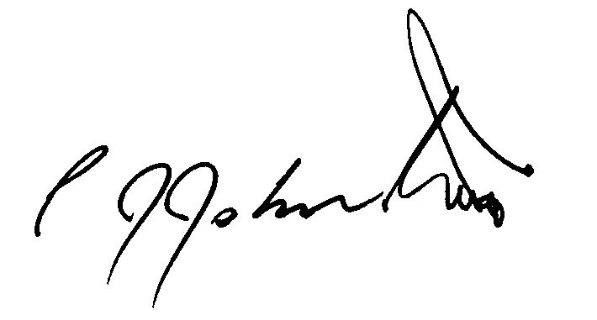
Philip Johnston

