**Anne Hollonds**

**National Children’s Commissioner**

**Help way earlier!’: How Australia can transform child justice and improve safety and wellbeing**

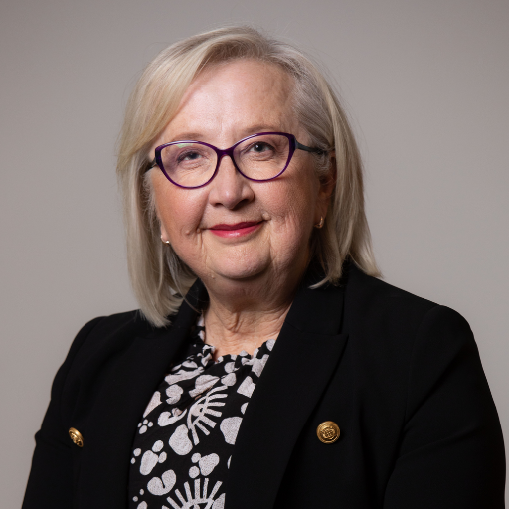

Wednesday, 2 October 2024

The National Press Club of Australia

Anne Hollonds, National Children’s Commissioner, will Address the National Press Club of Australia on "Help way earlier!’: How Australia can transform child justice and improve safety and wellbeing".

Over the last 12 months, National Children’s Commissioner Anne Hollonds has led the development of a major new report which is calling for a shakeup of how our federal, state and territory governments approach child justice and the wellbeing of children who are, or who are at risk of being caught up in the criminal justice system.

The focus of the report’s 24 recommendations is on elevating child wellbeing to be made a national priority, coordinating action on child justice reform across Australia’s federation, and ensuring reform is based on evidence and human rights.

The report’s findings and recommendations are based on submissions, interviews and consultations with hundreds of stakeholders and experts across Australia. Importantly, this included more than 150 children and young people who have been or are at risk of being in contact with police and criminal justice systems, or in youth detention.

In this address, Commissioner Hollonds will detail the findings of the report, unpack the key recommendations for reform and highlight the voices of the children and families who are asking for ‘help way earlier’ so they can secure a better and safer future for themselves and their communities.

Commissioner Hollonds will address the barriers to action, including the role of the media, and how politics gets in the way of prevention, leading to our failure to ensure the wellbeing of Australia’s most vulnerable children.

[**https://humanrights.gov.au/our-work/childrens-rights/publications/help-way-earlier**](https://urldefense.proofpoint.com/v2/url?u=https-3A__humanrights.gov.au_our-2Dwork_childrens-2Drights_publications_help-2Dway-2Dearlier&d=DwMGaQ&c=euGZstcaTDllvimEN8b7jXrwqOf-v5A_CdpgnVfiiMM&r=CXhw1a8CZ9y5714RtnT2w9niWT8l8JSC6FqdqJzOaD0&m=Up3OCvhytZkcZXn3zGSlhW8LuYtAuV5btGKn3ob75r1CeeQi9ZXmCJYt5HUv80EB&s=aDYJOLp1Us_Oe26n1V5RynhOPyw1-AKCVwUSzoSCXGk&e=)

**Bio**

Anne Hollonds is Australia’s National Children’s Commissioner, a role based at the Australian Human Rights Commission.

The National Children’s Commissioner monitors policy and legislation to ensure that the human rights of children are protected and promoted, and provides advice to government.

Formerly Director of the Australian Institute of Family Studies, for 23 years Anne was Chief Executive of government and non-government organisations focused on research, policy and practice in child and family wellbeing.

As a psychologist Anne has worked extensively in frontline practice, including in child protection, domestic, family and sexual violence, mental health, child and family counselling, parenting education, family law counselling, and community development. She currently contributes to numerous expert advisory groups.